Sustainability Report
2025

Thermocast S.p.A.

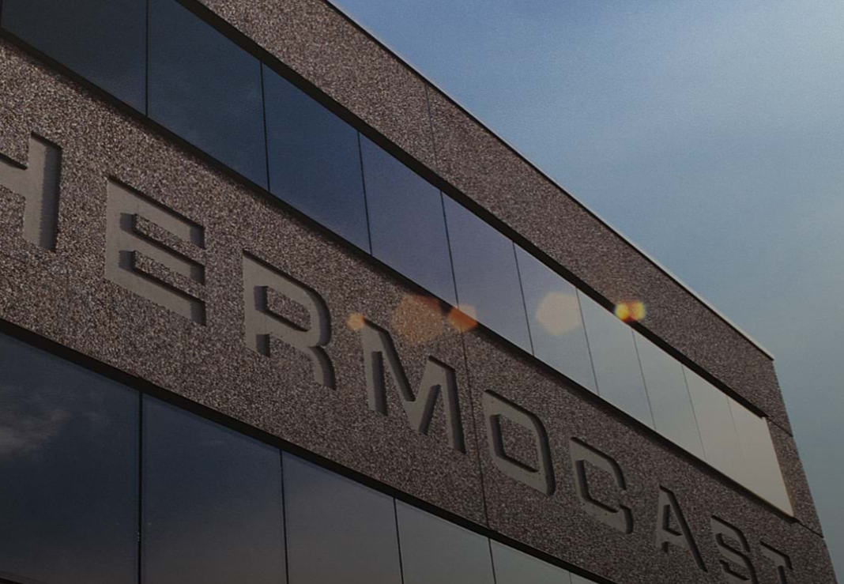

Table of contents
1. Thermocast and ESG 3
1.1 General Profile 3
1.2 Governance 7
1.3 Double Materiality 9
1.4 Vision and values 10
1.5 Strategic plan for energy transition 10
1.6 Policies and Targets 11
2. Environment 14
2.1 Energy 14
2.2 GHG Emissions 16
2.3 Raw materials 21
2.4 Waste 24
2.5 Water 27
2.6 Pollution 28
2.7 Biodiversity 29
2.8 Physical risk 30
3. People at Thermocast 30
3.1 employees 31
3.2 Employees training and development 33
3.3 Collective bargaining and social dialogue 33
3.4 The remuneration system 34
3.5 Non-discrimination, diversity, and equal opportunities 34
3.6 H&S 35
3.7 Dispute 36
3.8 Further information 37
4. Governance 37
4.1 Prevention and detection of corruption and extortion 37
4.2 Supplier relations and payment practices 37
Methodological note 41

1. Thermocast and ESG

1.1 General Profile
VSME B1–C1–C8
Thermocast S.p.A. (hereinafter also referred to as “Thermocast” or the “Company”) operates in the metallurgical sector, boasting thirty years of experience in the production of steel castings and high-performance alloys resistant to high temperatures and corrosion.
Thermocast does not operate in sectors considered high-risk by the European Union. Furthermore, the Company is not excluded from the EU benchmark parameters aligned with the Paris Agreement.
The Company has its registered office and production site at Via Francesco Lazzarini da Caravaggio 8, 24043, Caravaggio (BG), where all production, administrative, and support activities are concentrated.

Ownership setup and corporate structure
Thermocast is a joint-stock company with a family-owned structure. The share capital of 2.5 million euros is mostly held by Paolo Raffaelli (father) and Francesco Raffaelli (son), who own 72.5% together, while the remaining 27.5% consists of treasury shares.

Business model and ESG

Business areas and products
Thermocast operates in 5 main business areas (compared to 2025 revenues):
96.5%
2025
Steel industry
Design and manufacture of various components, such as rollers, radiant tubes, heat recovers, and oven riders, as well as other solutions tailored to the specific application needs of the sector.

2.3%
2025
Cement industry
Design and production of parts, such as scraper chains, hammers, kiln discharge sectors, and cooling grates.

0.2%
2025
Heat treatment
Careful selection of materials to get the best performance from products like fused tapes, mitts, fans, and grates.

0.6%
2025
Waste disposal
Production of high-quality briquettes intended for waste treatment and incineration plants.

0.4%
2025
Other applications
Development of precise projects for various industrial sectors. The main products are: pipe supports in the chemical and petrochemical sector, castings for the glass industry, customized solutions for every application.

All the products offered by Thermocast in the different business areas can be supplied raw, or finished through mechanical work and assembly processes, depending on the technical specifications and customer needs.

Main customers
Thermocast operates exclusively through the Business-to-Business (B2B) channel.
In 2025, Thermocast customer base is mostly made up of end users (73.2%), specifically steel mills and steel complexes that use the components directly in furnaces and in steel processing and transformation lines.
Next are distributors (13.4%) and plant manufacturers (10.0%), who integrate the components into machinery and industrial systems. The remaining share is made up of traders (3.4%), who buy the products for resale on the market.
Below is the breakdown of 2025 revenue by customer type.


Italy 13.6%

30 nations
48% revenues UE
52% revenues Extra-UE
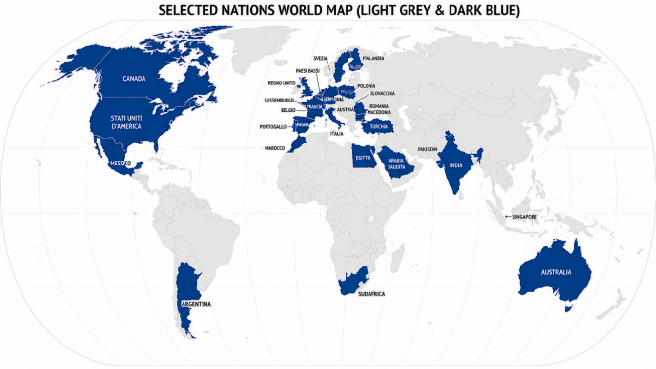

Financials
The main economic and financial indicators, expressed in thousands of euros, are set out below.

Financial KPI
KPI | 2025 | 2024
Revenue from sales and services | 34 483.5 € | 35 045.9 €
Total assets on the balance sheet | 31 451.7 € | 26 546.8 €

Organizational Chart

The organizational chart for Thermocast for the year 2025 is presented below.

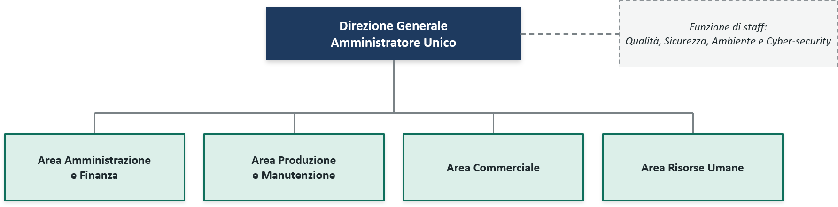

1.2 Governance
VSME B2–C2–C9

Bodies and their composition
Thermocast adopts a traditional corporate governance system.


The administrative body consists of a Sole Director, identified as Francesco Raffaelli.
BOARD
Index = 0
Gender diversity

EXECUTIVE POWER AND INDEPENDENCE OF THE ADMINISTRATIVE BODY
Role | Executive | Independent
AD | X

In 2025, Thermocast established a committee with sustainability functions, known as the ESG Steering Committee (ESG SC), composed of the following four members:

COMPOSITION BY ESG STEERING COMMITTEE TYPE
Role | Men | Women
AD | X
QHSE Manager |  | X
Plant Manager | X
External ESG Advisor |  | X
Steering comittee
Index = 1
Gender diversity
The ESG Steering Committee meets periodically (at least four times a year) with the following responsibilities:
• driving the achievement of 2030 ESG targets;
• authorizing the annual ESG action plan and any necessary accelerations during the year;
• approving the Sustainability Report on an annual basis.
A Board of Statutory Auditors is also in place to act as the supervisory body.
Statutory auditing is entrusted to the audit firm. REVI4 S.r.l.

COMPOSITION BY TYPE OF BOARD OF STATUTORY AUDITORS
Nome (Role) | Men | Women
Rigamonti Giorgio Luigi (Chairman) | X
Nava Daniela (Sindaco) |  | X
Vescovi Alex (Sindaco) | X
Carminati Luca (Sindaco supplente) | X
Vinciguerra Luca Matteo (Sindaco supplente) | X
Collegio Sindacale
Index = 0,25
Gender diversity

1.3 Double Materiality
Nel corso del 2025, Thermocast ha condotto un primo esercizio di analisi di doppia materialità, che è stato verificato da un consulente esterno indipendente, approvato dall'Amministratore Unico. Al fine di garantirne la continua rilevanza rispetto al contesto aziendale e agli stakeholder di riferimento, l’analisi sarà sottoposta a riesame con cadenza almeno triennale, nonché in presenza di significative modifiche del contesto operativo, organizzativo o strategico della Società.
The analysis, developed in alignment with the principles introduced by the Corporate Sustainability Reporting Directive (CSRD) and the European Sustainability Reporting Standards (ESRS), serves as a fundamental tool for identifying and assessing the impacts, risks, and opportunities (IRO) associated with environmental, social, and governance (ESG) matters.
The analysis conducted is based on the double materiality perspective set out in the ESRS:
• impact materiality (inside-out), which considers the positive and negative effects generated by the Company’s activities on people and the environment, including through stakeholder engagement;
• financial materiality (outside-in), which assesses how external sustainability factors can influence the Company’s economic and financial performance.
The analysis process, carried out taking into account the specific characteristics of the steel melting sector, identified four material topics—CO₂ and climate change, Health and safety, Customers and product eco-design, and Governance and risks—which can be broadly categorized under environmental issues, health and safety, and stakeholder engagement.

The findings of the double materiality analysis serve as the primary reference for defining and updating the Company’s sustainability strategy. Specifically, Thermocast S.p.A.’s strategy is based on key elements linked to the sustainability topics deemed most significant, with particular emphasis on environmental aspects, health and safety, and stakeholder engagement. Based on the analysis results, the Company has also developed its policies and defined ESG objectives with a 2030 time horizon. For further details, please refer to section 1.6, “Policies and objectives.”
In line with these results, Thermocast subsequently undertook an initial exercise to align with the United Nations Sustainable Development Goals (SDGs), identifying the four areas where it believes it can make the greatest contribution through its activities: SDG 6 – Clean Water and Sanitation, SDG 8 – Decent Work and Economic Growth, SDG 12 – Responsible Consumption and Production, and SDG 13 – Climate Action.
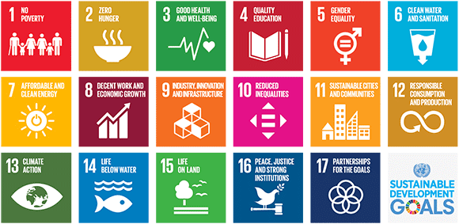

These objectives are consistent with and directly linked to the material topics identified through the double materiality analysis (Environment, Health and Safety, Stakeholder Engagement).
In line with its approach to sustainability, Thermocast also draws inspiration from the ten principles of the United Nations Global Compact (UNGC), promoting responsible conduct regarding human rights, working conditions, environmental protection, and the fight against corruption.

1.4 Vision and values
“Imagine a world where industries across every sector—from metallurgy to glass, cement, and petrochemicals—operate with maximum efficiency and safety. This is the world we shape at Thermocast, thanks to components tailored to your specific needs.
With a team of experts and cutting-edge technologies, we create custom components that exceed expectations.
We work side-by-side with you to gain a deep understanding of your requirements through a proactive, problem-solving approach, thereby ensuring highly effective solutions.”

Experience, customization, problem-solving, and innovation represent the core values ​​of Thermocast’s business, guiding its strategic, operational, and relational decisions.

 |  |  | 
Experience  To put the right expertise at your disposal | Customization  To offer you solutions that make a difference | Problem solving  Per affrontare insieme a te le sfide più interessanti | Problem solving  To tackle the most interesting challenges together with you

Thermocast’s vision and corporate values ​​are published on the company website and made accessible to all stakeholders.

1.5 Strategic plan for energy transition
VSME B2–C1–C2–C3
In alignment with the expectations of the 2015 Paris Agreement and following the mapping of Scope 1, Scope 2, and Scope 3 climate-impacting emissions, Thermocast established its climate change mitigation transition plan for 2030 in early 2026.
The Plan outlines 3 strategic levers for pursuing the reduction of climate-impacting emissions:
1. purchasing and using electricity sourced 100% from renewable sources backed by Guarantees of Origin, replacing electricity from fossil fuel sources (a goal already achieved in 2025; please refer to section 2.1, “Energy”);
2. purchasing and using thermal energy sourced 100% from biomethane, replacing natural gas;
3. engaging in dialogue with suppliers in Scope 3 category 1, “Purchased goods and services.”
Thermocast is not currently subject to the obligations set out in the EU Taxonomy Regulation. Nevertheless, decarbonization initiatives will be developed in alignment with the "Do No Significant Harm" (DNSH) principle, in order to avoid significant environmental impacts on other environmental objectives.
It should be noted that, during 2025, the Company did not undergo an assessment of its sustainability performance (e.g., ESG ratings and/or scores).

1.6 Policies and Targets
VSME B1–B2–C2–C3
Policies, tools, and management systems
Thermocast has formalized its principles, commitments, and objectives regarding sustainability, while simultaneously defining the tools and mechanisms necessary to ensure their implementation.
POLICIES AND TOOLS
Topic | Policy/Tool | Year
Business ethics | Code of Ethics | 2018
Anticorruption | Anticorruption Policy | 2024
Stakeholder Engagement | Stakeholder Engagement Policy | 2025
Stakeholder Engagement | Supplier Code of Conduct | 2024
Environment | Environemntal Policy | 2025
People | QHSE Policy | 2025
QHSE | QHSE Policy | 2025

At the same time, everyone working at Thermocast is expected—within the scope of their respective responsibilities and areas of expertise—to contribute to achieving ESG objectives and continuously improving the company's sustainability performance.
The Sole Director approves corporate policies, oversees their implementation, and monitors compliance.
These policies are periodically reviewed and updated in light of the results of the double materiality analysis, changes in the internal and external context, progress toward the 2030 ESG objectives, and international best practices and standards.
The policies are made available to internal and external stakeholders by being published on the company website.
Management systems
Management system | Reference | Third party | Registration number | First issue | Expiring date
Quality Management system | UNI EN ISO 9001:2015 |  | 0011889 | 22/05/2001 | 24/10/2027

Targets
In line with its corporate policies, Thermocast has defined ESG targets for 2030 aimed at guiding the continuous improvement of its sustainability performance.

TARGETS: Stakeholder engagement and Business Ethics
Objective | KPI | Target year and performance | 2025
Sites with managment systems implemented according to ISO 9001, ISO 14001, ISO 45001 | % | 2030  100% ISO 9001  100% ISO 14001  100% ISO 45001 | 100% ISO 9001
People informed about Code of Ethics | % | 2027  100% | 100% people under Code of Ethics
Suppliers at risk for ESG that signed the Code of Conduct | % of suppliers at risìk | 2028  50%  2030  90% | Corporate website
Training on ESG, not only QHSE | Training frequency | 2027  At least one training for all per year | 7 people and 62 QHSE training hours
Supplier meetings to accelerate innovation and reduce impacts on the environment | Frequenza incontri | 2027  At least one meeting per year

TARGETS: Environment
Objective | KPI | 2024 Target year and performance | 2030 Target year and performance | 2025
CO₂ Scope 1 + 2 reduction | Ton CO₂ eq | 407.0 ton CO₂eq  (Scope 1 + Scope 2 location based)  709.0 ton CO₂eq  (Scope 1 + Scope 2 market based) | -50%, corrispondente a:  - 203,5 ton CO₂eq  (Scope 1 + Scope 2 location based)  - 354,5 ton CO₂eq  (Scope 1 + Scope 2 market based) | 388.2 ton CO₂eq  (Scope 1 + Scope 2 location based)  120.3 ton CO₂eq  (Scope 1 + Scope 2 market based)
Water pollution cases | N. | / | 0 | 0
Recycled content | % sul totale | 66.7% | >67.8% | 67.8%
Raw materials with lower carbon footprint | Ton CO₂ eq | 10,292 ton CO₂eq | < 10,292 ton CO₂eq | 10,292 ton CO₂eq (proxy)
TARGETS: People
Objective | KPI | 2024 Target year and performance | 2030 Target year and performance | 2025
Injury rate (LTI FR) | Accidents/  worked hours x 1.000.000 | 34.90 | 26.51 | 18.12
Severity rate | Days of absence/  worked hours x 1.000 | 0.38 | 0.22 | 0.05
MBO linked to ESG | % of people with MBO linked to ESG | / | 100% of managers

2. Environment
VSME B2–C2
Thermocast places environmental protection at the heart of its strategies.
Recognizing the environmental impacts associated with its production activities, the Company promotes a development model focused on improving its environmental practices and performance, operating in compliance with applicable national and supranational regulations as well as its own voluntary commitments.
By formalizing an Environmental Policy—aligned with the principles of its Code of Ethics and QHSE (Quality, Health, Safety, and Environment) Policy—Thermocast commits to preventing and reducing environmental impacts arising from its business activities. It does so by constantly monitoring relevant environmental aspects and promoting the adoption of practices and technologies designed to minimize environmental effects.
To support this commitment, the Company establishes improvement objectives and periodically monitors their achievement using specific performance indicators (KPIs). Please refer to section 1.6, "Objectives and targets," for further details.
Through its Supplier Code of Conduct, Thermocast extends its Environmental Policy to its value chain, requiring partners to respect the environment, use resources efficiently, reduce emissions, and adopt practices aligned with the ISO 14001 standard.
Thermocast encourages the active involvement of all personnel working within the plant and across the supply chain to foster the adoption and application of the principles the Company promotes regarding environmental management..

2.1 Energy
VSME B3–C2
During 2025, Thermocast total energy consumption amounted to 1593,3 MWh.

2025 ENRGY CONSUMPTION (MWh)
Type | MWh | %
Electricity | 1038.1 | 65.2%
Natural gas | 398.1 | 25.0%
Diesel | 142.6 | 9.0%
Petrol | 14.5 | 0.8%
Total | 1593.3 | 100.0%

It is noted that the primary component of energy consumption is electricity (65.2% of the total), used to power production processes as well as to light offices and production areas.
Next is natural gas consumption, accounting for 25.0% (398.1 MWh), which is attributable to the energy required for heating workspaces.
Fuel consumption (petrol and diesel) (9.8% of the total) is linked to the company fleet, which consists of vehicles used for both business and mixed purposes.
Regarding the breakdown between renewable and non-renewable energy, energy consumption can be categorized as follows, considering the two broad consumption categories of fuels and electricity.

2025 ENERGY CONSUMPTION PER TYPE (MWh)
Type | MWh | %
Consumption of non-renewable fuels | 555.2 | 34.8%
Natural gas | 398.1 | 25.0%
Diesel | 142.6 | 9.0%
Petrol | 14.5 | 0.8%
Consumption of renewable fuels | - | -
Consumption of non-renewable electricity | - | -
Consumption of renewable electricity | 1038.1 | 65.2%
Total | 1593.4 | 100.0%

In 2025, 65.2% of Thermocast’s energy consumption is derived from renewable sources. This figure corresponds entirely to the electricity purchased during the year, as the Company has entered into a supply contract for 100% renewable electricity, certified through Guarantees of Origin.
The remaining portion of energy consumption (34.8%) comes from non-renewable sources—such as natural gas, diesel, and petrol—used for plant operations, space heating, and operational activities.

2.2 GHG Emissions
VSME B3–C2–C3
Thermocast considers the management of GHG emissions a priority area within its sustainability journey and its efforts to reduce environmental impacts. In this context, the Company places particular emphasis on monitoring and reducing climate-impacting emissions, in line with the reduction targets defined in section 1.6, “Policies and objectives.”.
To ensure adequate oversight of the issue and comprehensive monitoring of its environmental performance, Thermocast has mapped its Scope 1, Scope 2, and Scope 3 greenhouse gas emissions.
Scope 1 | Direct emissions produced by sources owned or controlled by the company, such as the use of fuel for company vehicles and natural gas for heating.
Scope 2 | Indirect emissions from electricity purchased and consumed at company sites
Scope 3 | Indirect emissions generated along the value chain—both upstream and downstream of the company's operations—resulting, for example, from the purchase of goods and services, transportation, business travel, and employee commuting

CO_{2eq} Scope 1 emissions
In 2025, Thermocast Scope 1 climate-impacting emissions are distributed as follows:

SCOPE 1 per source (ton CO_{2 eq})
Type | 2025 | % | 2024 | %
Stationary combustion (natural gas) | 80.7 | 67.1% | 67.0 | 57.3%
Mobile combustion (petrol and diesel) | 39.6 | 32.9% | 50.0 | 42.7%
Fugitive emissions | - | - | - | -
Total | 120.3 | 100.0% | 117.0 | 100.0%

Regarding the management of fluorinated gases in air conditioning systems, Thermocast ensures compliance with relevant regulatory obligations by inventorying equipment, properly maintaining systems, preventing potential leaks, and conducting periodic checks performed by qualified third-party operators and firms.
No fugitive emissions attributable to air conditioning systems were recorded during the two-year reporting period.

CO_{2eq} Scope 2 emissions
The location-based and market-based approaches were used to calculate indirect climate-changing emissions (Scope 2) resulting from the purchase of electricity.
The location-based methodology involves calculating climate-changing gas emissions by applying national average emission factors based on the mix of primary energy sources used to generate electricity (energy mix).
In contrast, the market-based methodology requires calculating emissions from purchased electricity and heat by accounting for the share of electricity from renewable sources (backed by Guarantees of Origin)—to which an emission factor of zero is assigned—and applying the Residual Mix emission factor to the remaining emissions. For the market-based approach, the share of self-generated renewable energy was deducted from the total energy purchased and consumed by the Group’s companies.
The Scope 2 emissions generated over the last two years are presented below, highlighting the two calculation approaches used.

SCOPE 2 (ton CO_{2 eq})
Type | 2025 | 2024
CO_{2eq} Scope 2 – location-based | 267.9 | 290.0
CO_{2eq} Scope 2 – market-based | - | 592.0

It is noted that, in 2025, Scope 2 climate-altering emissions calculated using the market-based approach amount to zero, due to Thermocast sourcing of electricity derived 100% from renewable sources, certified by Guarantees of Origin.

CO_{2eq} Scope 3 emissions
Scope 3 climate-impacting emissions were calculated analytically for the year 2024. Given the stability of business volume, the types of goods purchased, and production processes, the resulting figure was also used as a proxy value for 2025. Scope 3 emissions for the 2025 financial year are presented below.

In the chart, Scope 3 categories other than “CAT. 1 – Purchased goods and services” have been aggregated under the heading “Other”.
The specific values ​​for each Scope 3 category analyzed are presented below

 | SCOPE 3 (ton CO_{2 eq})
Type |  | 2025 |  | % | 2024 | %
CAT.1 - Goods and services purchased |  |  | 17649.0 | 96.3% | 17649.0 | 96.3%
CAT.3 - Fuel- and energy-related activities not included in Scope 1 or 2 |  |  | 157.0 | 0.9% | 157.0 | 0.9%
CAT.4 - Upstream transport and distribution |  |  | 27.0 | 0.1% | 27.0 | 0.1%
CAT.5 - Waste produced in operationsi |  |  | 156.0 | 0.9% | 156.0 | 0.9%
CAT.6 - Business trips |  |  | 4.0 | 0.0% | 4.0 | 0.0%
CAT.7 - Employee home-to-work commutes |  |  | 1.0 | 0.0% | 1.0 | 0.0%
CAT.9 - Downstream transport and distribution |  |  | 330.0 | 1.8% | 330.0 | 1.8%
Total |  | 18324.0 |  | 100.0% | 18324.0 | 100.0%

As highlighted by the detailed data, Scope 3 GHG emissions are almost entirely attributable to category 1, “Purchased goods and services” (96.3%). For further details on the composition and origin of purchased materials, please refer to section 2.3, “Input materials.”
Regarding the Scope 3 categories excluded from the analysis, categories 2 (“Capital goods”) and 12 (“End-of-life treatment of sold products”) were assessed as non-significant. Conversely, categories 8 (“Upstream leased assets”), 10 (“Processing of sold products”), 11 (“Use of sold products”), 13 (“Downstream leased assets”), 14 (“Franchises”), and 15 (“Investments”) were found to be inapplicable given the characteristics of the operating model and business activities.

CO_{2eq} Scope 1 + Scope 2 + Scope 3 emissions
Presented in the next page are Thermocast total climate-impacting emissions—including Scope 1, Scope 2, and Scope 3—as well as the corresponding emission intensity indicators.

SCOPE 1 + SCOPE 2 + SCOPE 3 absolute (ton CO_{2 eq})
Type | 2025 | 2024
CO_{2eq} Scope 1 + Scope 2 location-based + Scope 3 | 18 712.2 | 18 731.0
CO_{2eq} Scope 1 + Scope 2 market-based + Scope 3 | 18 444.3 | 19 003.0

SCOPE 1 + SCOPE 2 + SCOPE 3 intensity
Type | 2025 | 2024
Revenues (€) | 34 483 535.0 | 35 045 908.0
CO_{2eq} Scope 1 + Scope 2 location-based + Scope 3 / Revenues * 1.000.000 | 542.6 | 534.5
CO_{2eq} Scope 1 + Scope 2 market-based + Scope 3 / Revenues * 1.000.000 | 534.9 | 542.6

2.3 Raw materials
VSME B7–C2
In 2025, Thermocast purchased a total of approximately 5 900 tonnes of materials.
The procurement mix is heavily concentrated on iron parts (3 742 tonnes), which account for 63.3% of the total, confirming their status as the primary material category used in the production process. Next are semi-finished and finished high-alloy steel castings, amounting to 1 447 tonnes (24.5% of the total).
Smaller shares consist of steel accessories (198 tonnes, or 3.4%) and high-alloy steel (130 tonnes, or 2.2%).
The remaining portion (6.7%) comprises a variety of metallic materials and components.

RAW MATERIALS (Kg)
Category | 2025 | % | 2024 | %
Steel components * | 198 467 | 3.4% | 213 331 | 3.3%
High-alloy steel | 129 510 | 2.2% | 60 464 | 0.9%
Cobalt | 20 500 | 0.3% | 20 750 | 0.3%
Chrome | 1 500 | 0.0% | 2 500 | 0.0%
Iron | 53 880 | 0.9% | 104 107 | 1.6%
Ferro-chromium | 77 000 | 1.3% | 87 820 | 1.4%
Ferromanganese | 1 000 | 0.0% | 1 500 | 0.0%
Ferromolybdenum | 500 | 0.0% | 500 | 0.0%
Ferroniobium | 1 450 | 0.0% | 750 | 0.0%
Ferrosilicon | 5 400 | 0.1% | 4 037 | 0.1%
Ferrotungsten | 9 500 | 0.2% | 4 250 | 0.1%
Ferrozirconium | - | - | 20 | 0.0%
Ferrovanadium | 10 | 0.0% | - | -
Semi-finished and finished  high-alloy steel castings | 1 446 728 | 24.5% | 1 382 673 | 21.4%
Cast iron | 17 720 | 0.3% | 5 000 | 0.1%
Graphite | 505 | 0.0% | 500 | 0.0%
Gaskets * | 1 601 | 0.0% | 45 021 | 0.7%
Molybdenum metal | 410 | 0.0% | - | -
Nickel | 95 203 | 1.6% | 60 000 | 0.9%
Nickel-magnesium | 20 | 0.0% | - | -
High-alloy steel parts * | 89 186 | 1.5% | 40 896 | 0.6%
Bronze pieces | 78 | 0.0% | 30 | 0.0%
Iron parts * | 3 742 483 | 63.3% | 4 374 689 | 67.6%
Cast iron parts * | 16 219 | 0.3% | 57 645 | 0.9%
Ferrous scrap | 1 441 | 0.0% | 291 | 0.0%
Tungsten metal | 250 | 0.0% | - | -
Total | 5 910 560 | 100.0% | 6 466 774 | 100.0%
* The weight in kg of these incoming materials was estimated based on their respective average price per kg (€/kg).

Material circularity
Recycled input rate: > 67%

Thermocast primarily uses recycled material (scrap, shavings, and production waste reintroduced into the production cycle) instead of virgin raw materials (such as ferroalloys or mined ore).

Product recyclability at end-of-life: 100%
The special alloys and steel components manufactured at the company's plant can be fully remelted and reused as secondary raw material for new production, eliminating end-of-life industrial waste and reducing the carbon footprint associated with extracting new resources.
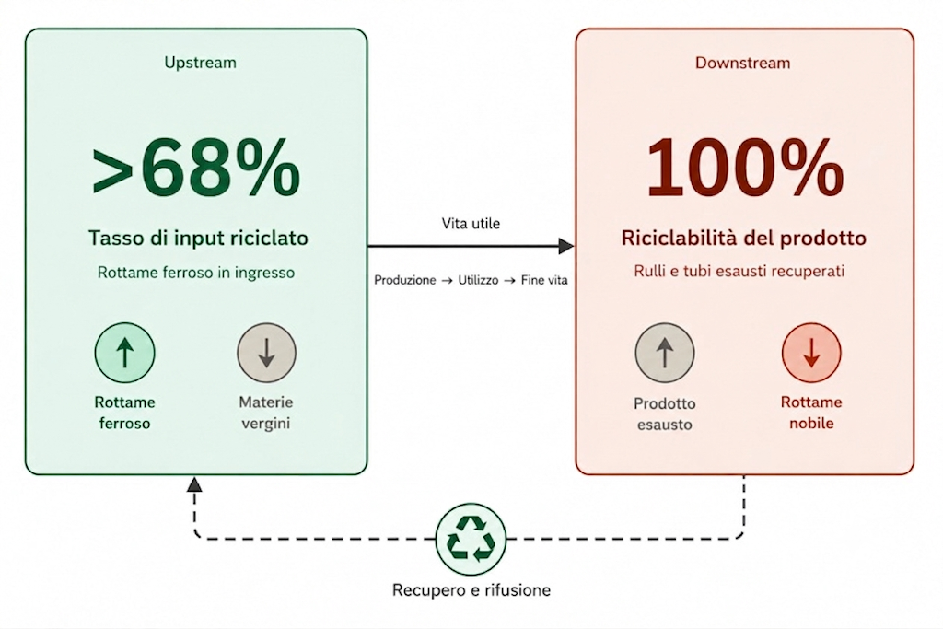

Regarding the composition of the packaging purchased and used by Thermocast, it is noted that this consists of wooden pallets and crates manufactured to order.
Packaging purchases account for less than 1% of the Income Statement; consequently, their management is not considered a material issue, and their quantities and composition are not tracked.

2.4 Waste
VSME B7–C2
In line with circular economy principles, in 2025 Thermocast implemented a system to monitor the waste it produces, aiming to minimize the quantity of waste generated and ensure proper treatment and disposal where recycling or recovery is not possible.
Waste is identified in accordance with the European Waste Catalogue (EWC), which classifies waste types as established by Directive 75/442/EEC. Within the scope of waste management, the list of EWC codes is divided into non-hazardous and hazardous categories. By convention, hazardous waste is marked with an asterisk (*).
The breakdown of produced waste by destination is presented in the next page.

The majority of the waste (201.3 tonnes, or 92.8%) was sent for recycling or recovery operations. The remaining 7.2% (15.6 tonnes), however, was sent for disposal.

It should be noted that Thermocast operations do not generate radioactive waste.

WASTE BY DESTINATION 2025 (kg)
Type | Code | kg | %
Waste destined for chemical, physical, or biological treatment | D9 | 12 510 | 5.8%
Waste destined for temporary storage | D15 | 3 110 | 1.4%
Waste destined for recycling or recovery | R13 | 201 290 | 92.8%
Total |  | 216 910 | 100.0%

PRODUCED WASTE by category (kg)
Category |  | Waste not destined for disposal | Waste destined for disposal | Waste generated | Waste generated
 |  | kg | kg | kg | %
Hazardous waste
CER 120109* | Halogen-free emulsions and solutions for machinery | 2 680 | / | 2 680 | 1.2%
CER 150110* | Packaging containing residues of hazardous substances or contaminated by such substances | 3 420 | / | 3 420 | 1.6%
CER 161103* | Other linings and refractory materials from metallurgical processes containing hazardous substances | / | 7 300 | 7 300 | 3.4%
Total hazardous waste by destination |  | 6 100 | 7 300 | 13 400 | 6.2%
Non Hazardous waste
CER 080120 | Aqueous suspensions containing paints or varnishes other than those mentioned in entry 08 01 19 | / | 5 210 | 5 210 | 2.4%
CER 080318 | Spent printing toners other than those mentioned in entry 08 03 17 | 10 | / | 10 | 0.0%
CER 100903 | Primary aluminum smelting dross | 16 640 | / | 16 640 | 7.7%
CER 100908 | Casting moulds and cores other than those mentioned in entry 10 09 07 | 126 000 | / | 126 000 | 58.1%
CER 100916 | Crack-detecting waste other than those mentioned in entry 10 09 15 | / | 3.110 | 3 110 | 1.4%
CER 120117 | Blasting material residues other than those mentioned in entry 12 01 16 | 33 900 | / | 33 900 | 15.6%
CER 150101 | Paper and cardboard packaging | 740 | / | 740 | 0.3%
CER 150102 | Plastic packaging | 480 | / | 480 | 0.2%
CER 150103 | Wooden packaging | 8 780 | / | 8 780 | 4.0%
CER 150104 | Metal packaging | 2 580 | / | 2 580 | 1.2%
CER 150106 | Mixed-material packaging | 5 920 | / | 5 920 | 2.7%
CER 150203 | Absorbents, filter materials, wiping cloths and protective clothing other than those mentioned in 15 02 02 | 140 | / | 140 | 0.1%
Total non-hazardous waste by destination |  | 195 190 | 8 320 | 203 510 | 93.8%
Total Waste |  | 201 290 | 15 620 | 216 910 | 100.0%

2.5 Water
VSME B6
Water resource management is a matter of primary importance for Thermocast. Monitoring water withdrawals makes it possible to assess water usage and promote efficient consumption. Furthermore, ensuring proper usage aligns with the Company’s objective of preventing any form of water resource pollution, as outlined in paragraph 1.6, "Objectives and Targets."
During 2025, Thermocast S.p.A.’s Caravaggio site withdrew a total of 54,024 m³ of water, sourced almost exclusively (99.0%, or 53,488 m³) from wells.
All withdrawn water is fresh water (≤1,000 mg/l total dissolved solids), used for sanitary purposes and as cooling water within the production cycle.
The withdrawn water is discharged entirely into the sewer system.

WATER WITHDRAWAL 2025 (m³)
Type | m³ | %
Water withdrawal from municipal supply | 536 | 1.0%
Water withdrawal from wells | 53 488 | 99.0%
Water withdrawal | 54 024 | 100.0%
Of which from water-stressed areas | - | -
Water discharge | 54 024 | 100.0%
Water consumption | - | -

Regarding the issue of water stress, the Thermocast S.p.A. site—located in Caravaggio (Bergamo)—is situated in an area with low water stress risk (<10%). This figure was obtained using the WWF Water Risk Filter tool, which maps and assesses water risk globally, classifying various geographical areas based on water stress levels and other environmental and territorial indicators.
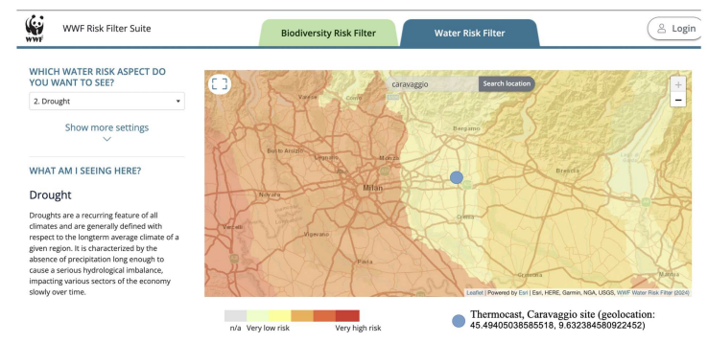

2.6 Pollution
VSME B4
Thermocast implements an annual atmospheric emissions monitoring plan at its Caravaggio (BG) plant, aimed at verifying and controlling environmental impacts related to air pollution.
The monitoring covers various emission parameters: total dust (dust stabilized at 105°C), free crystalline silica, sulfur oxides (SO2), metals, polycyclic aromatic hydrocarbons (PAHs), formaldehyde, phenol, furfural, p-toluenesulfonic acid, and total gaseous organic carbon.
Analyses conducted in 2025 showed values ​​fully compliant with the limits established by Authorization Decree no. 1623 of July 29, 2014, and subsequent amendments and additions.
WATER POLLUTION
Type | 2025 | 2024
Cases of water pollution | 0 | 0

Furthermore, the Company conducts periodic monitoring of wastewater discharges into the sewer system from its Caravaggio (BG) site, aimed at verifying and controlling environmental impacts related to water pollution.
The monitoring covers various physicochemical parameters and pollutants: pH, total suspended solids, biochemical oxygen demand (BOD), chemical oxygen demand (COD), total bound nitrogen, total chromium, total phosphorus, nickel, animal and vegetable fats and oils, total hydrocarbons, anionic surfactants, non-ionic surfactants, and total surfactants.
Analyses conducted in 2025 showed values ​​fully compliant with the limits established by Legislative Decree 152/2006 and applicable authorizations.

2.7 Biodiversity
VSME B5
Biodiversity is a significant factor in the management of environmental issues and the assessment of impacts associated with corporate activities. Its protection is an integral part of the Company’s commitment to the sustainable management of its operations.
Using the Natura 2000 tool, it was verified that the Thermocast site in Caravaggio (Bergamo) is located neither within nor in the vicinity of areas sensitive to biodiversity.

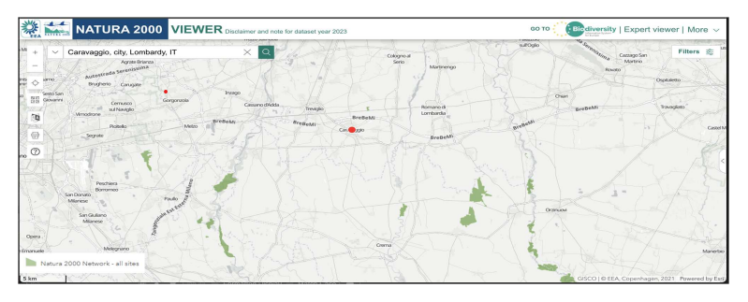
The Caravaggio site covers a total land area of ​​10,784 m², 100% of which is sealed. There are no nature-oriented areas either within or outside the site.
USE OF SOIL (MQ)
Address | Location | Type | mq | %
Via Francesco Lazzarini da Caravaggio 8, 24043, Caravaggio (BG) | Property | Waterproofed area | 2 292 | 21.3%
 | Lease | Waterproofed area | 8 492 | 78.7%
Total |  |  | 10 784 | 100.0%

2.8 Physical risk
Recognizing its increasing exposure to risks arising from catastrophic events and phenomena of various kinds, Thermocast has adopted appropriate mitigation measures by taking out specific insurance policies to cover key operational and environmental risks.
The insurance policies taken out by the Company are listed below.
Site | Insured asset | Insured physical risk/natural disaster | Insured amount  (mln €) | Coverage period
Caravaggio | Buildings | Fires, weather events, catastrophes | 9,5 mln €* | 31/12/2025
Caravaggio | Machinery | Fires, weather events, catastrophes | 2,0 mln €* | 31/12/2025
* The insured amount refers to a set of inseparable risks and therefore represents the total value of the insurance coverage.

Over the past three years, there have been no violations of environmental regulations.

3. People at Thermocast
VSME B2–
C2–C6

Thermocast’s commitment to its people is primarily expressed through its Code of Ethics, which identifies respect for individuals as a core principle.

In alignment with the United Nations Universal Declaration of Human Rights, Thermocast is committed to ensuring work environments that respect individual dignity, opposing any form of intolerance, harassment, violence, or discrimination based on gender, age, nationality, sexual orientation, religious or political beliefs, health status, or socioeconomic background.
The Code of Ethics also enshrines the principles of equal opportunity and the recognition of merit, stipulating that recruitment, professional development, and remuneration processes must be based exclusively on skills, professionalism, experience, and performance, while actively opposing favoritism and discrimination of any kind.
Finally, employment relationships are managed in full compliance with applicable laws and the relevant National Collective Labour Agreement (CCNL).

The protection of health and safety represents another pillar of Thermocast’s approach to people management. The Code of Ethics recognizes workplace safety and the protection of workers' physical and mental well-being as fundamental values, committing the Company to compliance with applicable regulations and to the promotion of prevention, training, and a culture of safety.
This commitment is embodied in the QHSE Policy, which guides corporate decisions toward risk reduction and continuous improvement in health and safety performance. This is achieved through risk assessment and mitigation, the setting of objectives monitored via specific indicators (see section 1.6 “Policies and objectives”), and the training and consultation of workers and their representatives on these matters.
Finally, the Occupational Health and Safety (OHS) Policy reinforces the promotion of a safety culture based on risk awareness and responsible behavior, extending to all parties interacting with the Company.
Thermocast’s commitment to respecting human rights extends beyond its internal operations to the entire supply chain. Through its Supplier Code of Conduct, the Company requires its partners to respect human rights and labor standards—specifically regarding the prohibition of child and forced labor, the promotion of lawful employment, the protection of worker health and safety, and the prevention of any form of discrimination, harassment, or behavior that undermines personal dignity.
In line with this approach, Thermocast has adopted a Stakeholder Engagement Policy that fosters dialogue with its stakeholders, including employees, collaborators, worker representatives, suppliers, and business partners. Thermocast values ​​listening and open discussion as tools for understanding needs and expectations and for building relationships based on trust.

3.1 employees
VSME B1–B8–C2–C5

Consistency and composition
As of the end of 2025, Thermocast’s workforce consists of 38 employees based at the Caravaggio (BG) site.
The Company does not utilize temporary agency workers or staff provided by third parties for its operations. Consequently, as of December 31, 2025, there are no non-employee workers within the organization.

The male predominance in the workforce is primarily due to the nature of certain operational roles, which tend to attract fewer applications from women.
Almost the entire Thermocast workforce (37 employees, or 97.4%) is employed under permanent contracts. This contractual structure reflects the Company’s commitment to job stability and the continuity of the employment relationship. The prevalence of permanent contracts ensures greater job security for employees, while also facilitating personal planning and easier access to financial and credit services.

All employees (100%) hold full-time contracts, aligning with organizational and production requirements—particularly given the nature of the work performed by the staff, the majority of whom are blue-collar workers. Nevertheless, the Company generally accommodates part-time requests, provided they are compatible with operational needs. No requests for part-time work were received in 2025.

The workforce composition aligns with the Company’s operational and organizational needs, reflecting an appropriate balance between production activities and support and coordination functions.
The workforce consists primarily of blue-collar workers; with 25 employees, they represent 65.8% of the total staff. There are 10 white-collar employees (26.3%). Finally, middle managers (3) account for 7.9% of the workforce.

3.2 Employees training and development
VSME B10
The training initiative involved 7 male employees, with an average of 8.9 hours per person, covering occupational health and safety.

TRAINING HOURS PER EMPLOYEE 2025
Type | Men | Women | Total
N. training hours | 62 | - | 62
N. employees | 30 | 8 | 38
N. training hours per employee |  |  | 1.6

3.3 Collective bargaining and social dialogue
VSME B10–C2
By applying the National Collective Labour Agreement (CCNL) for the Metalworking and Engineering Industry, Thermocast ensures a structured and consistent framework for determining the financial, regulatory, and organizational conditions applicable to its workforce.
This agreement serves as a vital safeguard, clearly defining—on a mutually agreed basis—workers' rights, duties, and protections, while fostering wage transparency and stability in employment relations.

100% of employees on the payroll as of December 31, 2025, are covered by the CCNL

3.4 The remuneration system
VSME B10–C2
Employee remuneration at Thermocast is determined in accordance with the parameters set by the applicable National Collective Labour Agreement (Metalworking Industry) and prevailing regulations.
100% of Thermocast employees receive remuneration equal to or higher than the prescribed statutory and contractual minimums.

3.5 Non-discrimination, diversity, and equal opportunities
VSME B8–B10–C2–C5
5

Employee composition by contract type, job classification, and gender
A gender-based analysis reveals that all eight female employees hold permanent contracts, whereas 96.7% of the men are employed on a permanent basis, with one male employee holding a fixed-term contract.
Regarding professional classification, women predominate in the middle management category (accounting for 66.7% of the total). Conversely, men are more represented in the other two categories—white-collar staff and blue-collar workers—with a marked majority among blue-collar workers. This composition aligns with the nature of the company's operations, which are primarily focused on production processes.

Contract breakdown by classification and gender (2025)
Category | Men | Women | Total
Permanent contract | 29 | 8 | 37
Managers | 1 | 2 | 3
White collars | 6 | 4 | 10
Blue collars | 22 | 2 | 24
Fixed-term contract | 1 | - | 1
Blue collars | 1 | - | 1
Total | 30 | 8 | 38

As of 2025, two workers belonging to protected categories are employed, in compliance with the employment obligations set forth by Law 68/1999.
These individuals were hired in collaboration with the social cooperative “Il Susino”.
PROTECTED CATEGORIES 2025
Type | N. of employees
N. employees with disabilities required by law | 2
N. employees with disabilities currently on staff | 2
N. employees with disabilities exceeding statutory requirements | 0

Remuneration by gender
Gender pay gap by category 2025
Type | Gender pay gap
Managers | -70.8%
White collars | +11.5%
Blue collars | -8.5%

In 2025, the gender pay gap analysis reveals pay disparities between men and women that vary according to the professional categories within Thermocast.
Specifically, the pay gap is particularly pronounced in the middle management category, where women earn an average salary 70.8% higher than that of men. A difference in favor of women is also observed in the blue-collar category—albeit to a lesser extent—with an average salary 8.5% higher than that of men.
Conversely, the trend is reversed in the white-collar category, where men earn an average salary 11.5% higher than women.
These differences are attributable to the workforce composition across various roles and the specific responsibilities associated with the positions held.

3.6 H&S
VSME B9–C2
5
During 2025, Thermocast implemented initiatives aimed at promoting workplace health and safety and strengthening a culture of prevention among staff.
In particular, the Company ensured the adoption of key measures required by occupational health and safety regulations, including the Risk Assessment Document (DVR) and the Emergency Plan, designed to ensure the rapid and safe evacuation of the Caravaggio production site.
At the same time, awareness-raising activities were promoted among workers, focusing specifically on the correct use of Personal Protective Equipment (PPE).
A monitor displaying the number of recorded accidents has been installed at the Caravaggio site to raise staff awareness and foster a culture of risk prevention.
Workers can report issues and potential risks through their Workers' Safety Representatives (RLS) during formal periodic meetings, as well as by making direct reports during daily operations. This system encourages active staff involvement in the timely identification of hazards. The key H&S performance indicators for the last two years are presented below.
H&S KPIs
Type | 2025 | 2024
N. recordable workplace injuries | 1 | 2
of which with absence from work | 1 | 2
of which without absence from work | 0 | 0
of which fatalities | 0 | 0
N. worked hours | 55 201 | 57 332
LTI FR (frequency index)  (n. accidents/ worked hours x 1.000.000) | 18.12 | 34.90
N. of recordable occupational diseases | 0 | 0
of which fatalities | 0 | 0
N. days of absence for accident and occupational diseases | 3 | 22
Severity rate (days of absence for accident/worked hourse x 1.000) | 0.05 | 0.38
*For calculation purposes, it is appropriate to take calendar days into account; consequently, days on which the person concerned is not scheduled to work (for example, weekends or public holidays) will count as lost days

Regarding Thermocast employees, there were two workplace accidents in 2024 and one in 2025; none were fatal. Following their physical and psychological recovery, all the individuals involved returned to their previous roles. There were no cases of occupational illness.

3.7 Dispute
VSME C7
5
Over the past three years, no final judgments or adverse rulings have been recorded against the Company regarding human rights violations involving Thermocast personnel.
Regarding employment matters, discussions are currently underway to reach an out-of-court settlement for a dispute raised by a former employee following an action taken in 2025. There are currently no pending labor lawsuits.
Finally, it is noted that during 2025, Thermocast did not become aware of any incidents involving end-users—or affected communities—caused by its products.

3.8 Further information
In 2025, Thermocast allocated ⁓5,000 euros to organizations for pursuing social objectives.

4. Governance

4.1 Prevention and detection of corruption and extortion
VSME B11–C2
5
Thermocast fosters a corporate culture grounded in the principles of legality, integrity, fairness, transparency, and the prevention of corruption and extortion.
The Company’s commitment in this area is formalized in its Code of Ethics and Anti-Corruption Policy. These documents prohibit fraudulent conduct, acts of corruption, and favoritism in professional and business dealings, as well as the offering of money, gifts, or other benefits to executives, officials, or employees of client or supplier companies—or to business associates—for the purpose of influencing their actions or securing undue advantages.
Particular attention is also paid to preventing conflicts of interest. All personnel are required to make decisions solely in the Company's interest, avoiding situations where personal, family, or financial interests might interfere with sound corporate governance and business management principles.
Through its Supplier Code of Conduct, Thermocast aims to extend its commitment to combating corruption and extortion to its supply chain by defining the expected principles and standards. The Company requires its business partners to operate in compliance with principles of integrity, fairness, and transparency, refraining from any form of corruption, undue pressure, or conflict of interest.
Over the past three years, there have been no instances of violations of the Code of Ethics or of applicable anti-corruption and anti-extortion laws. Furthermore, the Company has received no reports, initiated no disciplinary proceedings, and incurred no financial penalties or restrictive sanctions from competent authorities regarding conduct related to corruption.

4.2 Supplier relations and payment practices
VSME C1–C2–C7
5
Procurement policies and management
The management of relationships with suppliers and contractors is based on the principles of legality, fairness, transparency, and impartiality.
Supplier selection, as specified in the Code of Ethics and the Anti-Corruption Policy, relies on objective and non-discriminatory criteria. These take into account not only economic terms but also technical and organizational capabilities, operational suitability, commitment to environmental responsibility, and financial stability.
Furthermore, the Company fosters open dialogue with its suppliers to build efficient, transparent, and collaborative relationships. This approach is part of a broader Stakeholder Engagement Policy, through which Thermocast engages with stakeholders to understand expectations and needs across the entire value chain and to encourage consistent, responsible behavior throughout the supply chain.
In this context, Thermocast recognizes the importance of managing environmental, social, and economic aspects within its supply chain. Consequently, as part of its procurement process for goods and services, the Company has adopted a Supplier Code of Conduct, which outlines the ethical, social, environmental, and governance requirements and principles that suppliers must uphold in their dealings with the Company.

Payment terms and conditions

In 2025, Thermocast made payments for the purchase of goods and services (excluding utilities) to approximately 370 suppliers. The total value of payments made during the year amounted to approximately €20,500,000.
Data broken down by supply category and country is provided below.

BREAKDOWN OF SUPPLIERS AND SETTLED VALUE BY
SUPPLY CATEGORY 2025
Category | % Supplier  of the total | % Settled value €  of the total
Goods (excluding raw materials) | 36.6% | 60.5%
Services | 56.5% | 28.2%
Raw materials | 1.6% | 9.0%
Other | 5.3% | 2.3%
Total | 100.0% | 100.0%

Italy 39.1%

BREAKDOWN OF SUPPLIERS AND SETTLED VALUE BY
COUNTRY 2025
Category | % Supplier  of the total | % Settled value €  of the total
Africa | 1.9% | 51.8%
Italy | 87.9% | 39.1%
Europe | 6.2% | 4.5%
North America | 2.7% | 4.0%
Asia | 1.3% | 0.6%
Total | 100.0% | 100.0%

Regarding contractual payment terms and compliance therewith, data concerning payments made during 2025 is provided below.

Methodological note
This document, which constitutes the second edition of Thermocast Sustainability Report, covers the period from January 1, 2025, to December 31, 2025, aligning with the reporting period of the financial statements. The Sustainability Report is published on an annual basis.

This report has been prepared on a voluntary basis. Thermocast has decided to comply with:
• the requirements of the Voluntary Sustainability Reporting Standards for Non-listed SMEs (VSME) issued by EFRAG: application of the Basic Module and the Full Module.
References regarding the coverage of specific VSME data points are provided at the beginning of each section of this document.
• the provisions of the “SME-Bank Dialogue” banking framework: integration of quantitative datasets required for the assessment of creditworthiness and ESG risk factors, in accordance with national guidelines for the banking sector.
This approach aligns with the “Omnibus” regulatory package presented by the European Commission, which clarified that ESRS compliance is not mandatory for entities like Thermocast that fall outside the scope of the Corporate Sustainability Reporting Directive (CSRD).
The information presented in this document reflects the findings of an initial double materiality analysis—specifically, the negative and positive impacts, as well as the risks and opportunities, identified as material. The material topics forming the focus of this report were defined through an analysis process described in section 1.3, “Material Topics.”
Data have been calculated precisely based on the Company’s accounting and non-accounting records and other information systems, and validated by the relevant managers. Data determined using estimates are explicitly indicated.
This document has undergone a limited assurance review by the audit firm REVI4 S.r.l., in accordance with the international standard ISAE 3000 (Revised), and was approved by the administrative body and the Shareholders' Meeting on June 29, 2026.
The document can be downloaded from the Thermocast website at www.thermocast.it.
For further information, please contact: info@thermocast.it.
For the VSME content index and for the Dialogue on Sustainability between SMEs and Banks, please refer to the Italian version of the document.

United States of America, Egypt, Italy, France, Canada, Sweden, Belgium, India, Austria, Netherlands, South Africa, Turkey, Poland, Slovakia, Spain, Germany, Finland, Morocco, Romania, United Kingdom, Singapore, Australia, Saudi Arabia, Switzerland, Mexico, Portugal, Luxembourg, Pakistan, Macedonia, Argentina.
The gender diversity index is calculated like this: number of women / number of men
The conversion factors used in 2025 are those reported in the Department for Environment, Food and Rural Affairs (DEFRA) – 2025 – report: petrol L = 0.008969 MWh; natural gas Smc = 0.000796 t; natural gas kg = 12.674 MWh; diesel L = 0.009891 MWh. The fuel consumption of vehicles for mixed use is considered at 70%.
The conversion factors used in 2025 are those reported in the Department for Environment, Food and Rural Affairs (DEFRA) 2025 report – gasoline L = 0.00075 t; gasoline t = 2.778529 tCO2eq; natural gas Smc = 0.000796 t; natural gas t = 2.568164 tCO2eq; diesel L = 0.000834 t; diesel t = 3.014095 tCO2eq. The conversion factors used for F-GASES are the GWPs (Global Warming Potential): 1Kg = 2.008 kg CO2eq F-Gas (R410A - GWP 2.008). Fuel consumption for vehicles used for mixed purposes is considered at 70%. The conversion factors used in 2024 are the result of a calculation that combines fuel emission data from ISPRA (Italian Institute for Environmental Protection and Research) and the latest characterization factors from the IPCC (Intergovernmental Panel on Climate Change), 2021. Sixth Assessment Report (AR6). Available at: https://www.ipcc.ch/ (GWP 100a, 2021), European Commission.
I fattori di conversione utilizzati nel 2025 sono quelli riportati nel rapporto Italian Greenhouse Gas Inventory 1990-2023. National Inventory Document 2025" Annex 6 National Emission Factors – Istituto Superiore per la Protezione e la Ricerca Ambientale (ISPRA) https://emissioni.sina.isprambiente.it/inventario-nazionale/. L’emissione del National Inventory Report è annuale, di conseguenza per ogni anno sono stati utilizzati i dati del rapporto più recente. I fattori di conversione utilizzati nel 2024 sono quelli disponibili in Ecoinvent v 3.11 (2025), database internazionale e principale inventario di dati per studi di Life Cycle Assessment (LCA).
I fattori di conversione utilizzati nel 2024 sono quelli disponibili in Ecoinvent v 3.11, database internazionale e principale inventario di dati per studi di Life Cycle Assessment (LCA).
The gender pay gap is calculated as follows: (Total gross monthly male pay – Total gross monthly female pay) / Total gross monthly male pay × 100.

